Завдання №2

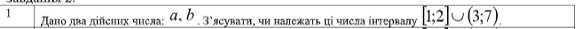
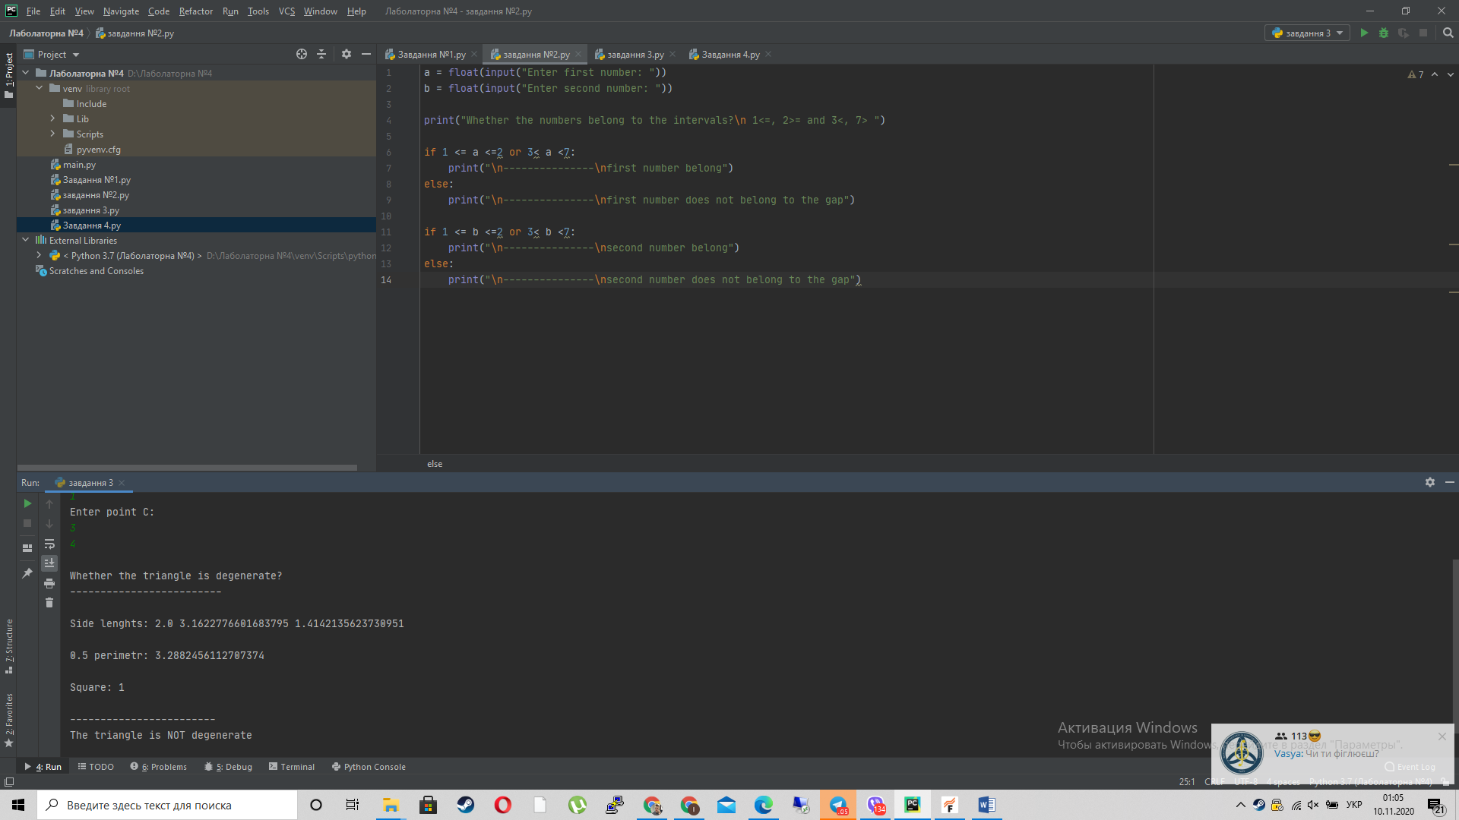

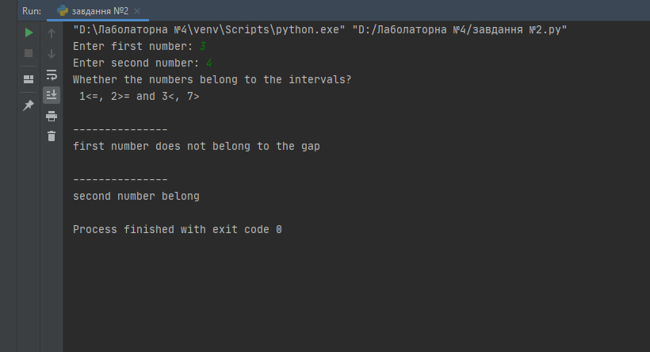
a = float(input("Enter first number: "))
b = float(input("Enter second number: "))
print("Whether the numbers belong to the intervals?\n 1<=, 2>= and 3<, 7> ")
if 1 <= a <=2 or 3< a <7:
print("\n---------------\nfirst number belong")
else:
print("\n---------------\nfirst number does not belong to the gap")
if 1 <= b <=2 or 3< b <7:
print("\n---------------\nsecond number belong")
else:
print("\n---------------\nsecond number does not belong to the gap")

Завдання №1

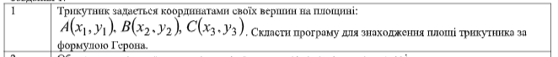
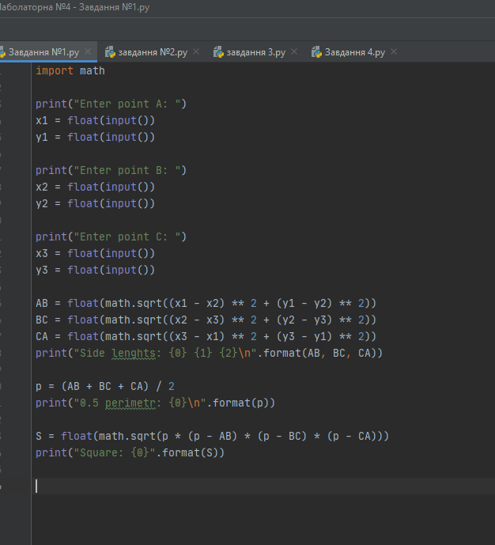

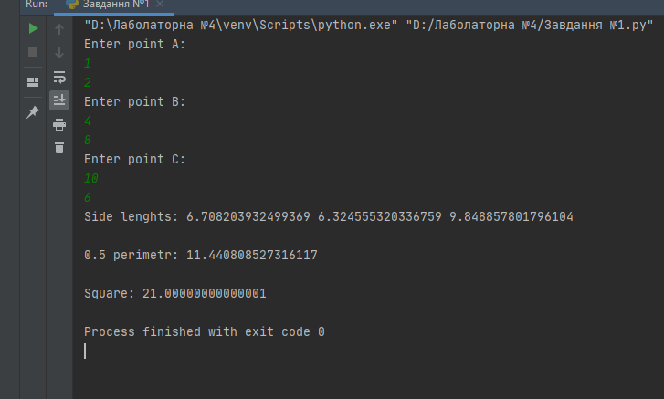
import math
print("Enter point A: ")
x1 = float(input())
y1 = float(input())
print("Enter point B: ")
x2 = float(input())
y2 = float(input())
print("Enter point C: ")
x3 = float(input())
y3 = float(input())
AB = float(math.sqrt((x1 - x2) ** 2 + (y1 - y2) ** 2))
BC = float(math.sqrt((x2 - x3) ** 2 + (y2 - y3) ** 2))
CA = float(math.sqrt((x3 - x1) ** 2 + (y3 - y1) ** 2))
print("Side lenghts: {0} {1} {2}\n".format(AB, BC, CA))
p = (AB + BC + CA) / 2
print("0.5 perimetr: {0}\n".format(p))
S = float(math.sqrt(p * (p - AB) * (p - BC) * (p - CA)))
print("Square: {0}".format(S))

Завдання № 3

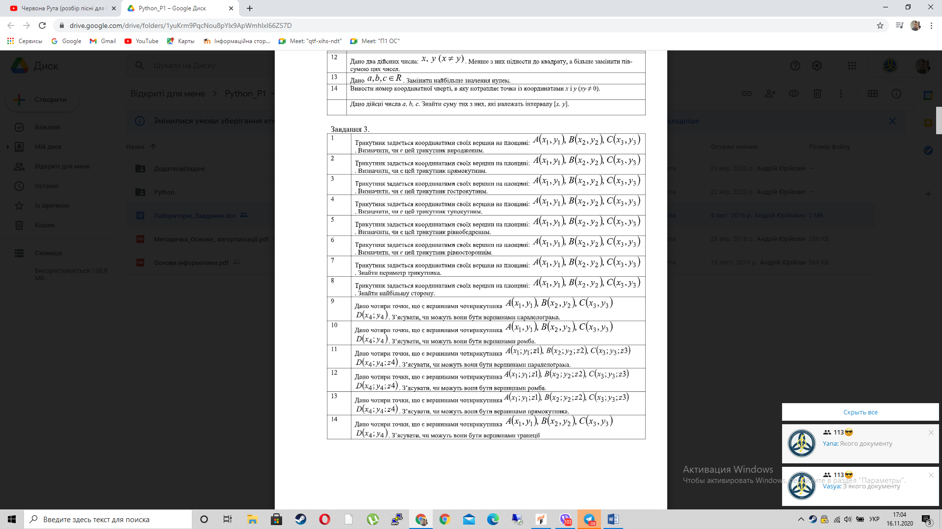
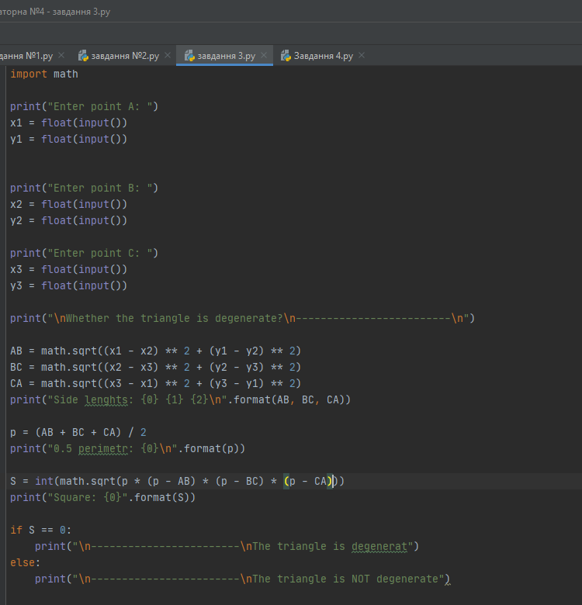

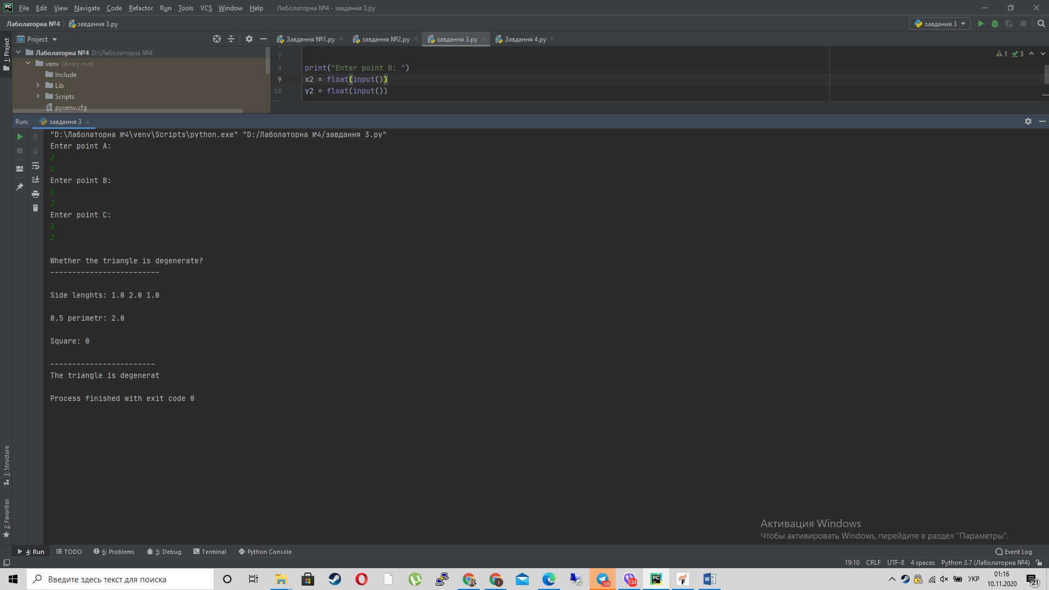
import math
print("Enter point A: ")
x1 = float(input())
y1 = float(input())
print("Enter point B: ")
x2 = float(input())
y2 = float(input())
print("Enter point C: ")
x3 = float(input())
y3 = float(input())
print("\nWhether the triangle is degenerate?\n-------------------------\n")
AB = math.sqrt((x1 - x2) ** 2 + (y1 - y2) ** 2)
BC = math.sqrt((x2 - x3) ** 2 + (y2 - y3) ** 2)
CA = math.sqrt((x3 - x1) ** 2 + (y3 - y1) ** 2)
print("Side lenghts: {0} {1} {2}\n".format(AB, BC, CA))
p = (AB + BC + CA) / 2
print("0.5 perimetr: {0}\n".format(p))
S = int(math.sqrt(p * (p - AB) * (p - BC) * (p - CA)))
print("Square: {0}".format(S))
if S == 0:
print("\n------------------------\nThe triangle is degenerat")
else:
print("\n------------------------\nThe triangle is NOT degenerate")

Завдання №4

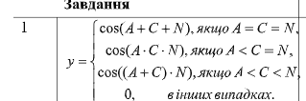
4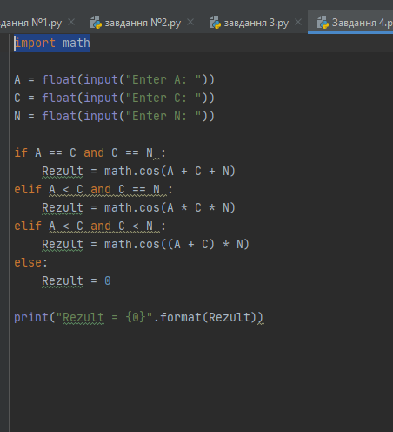

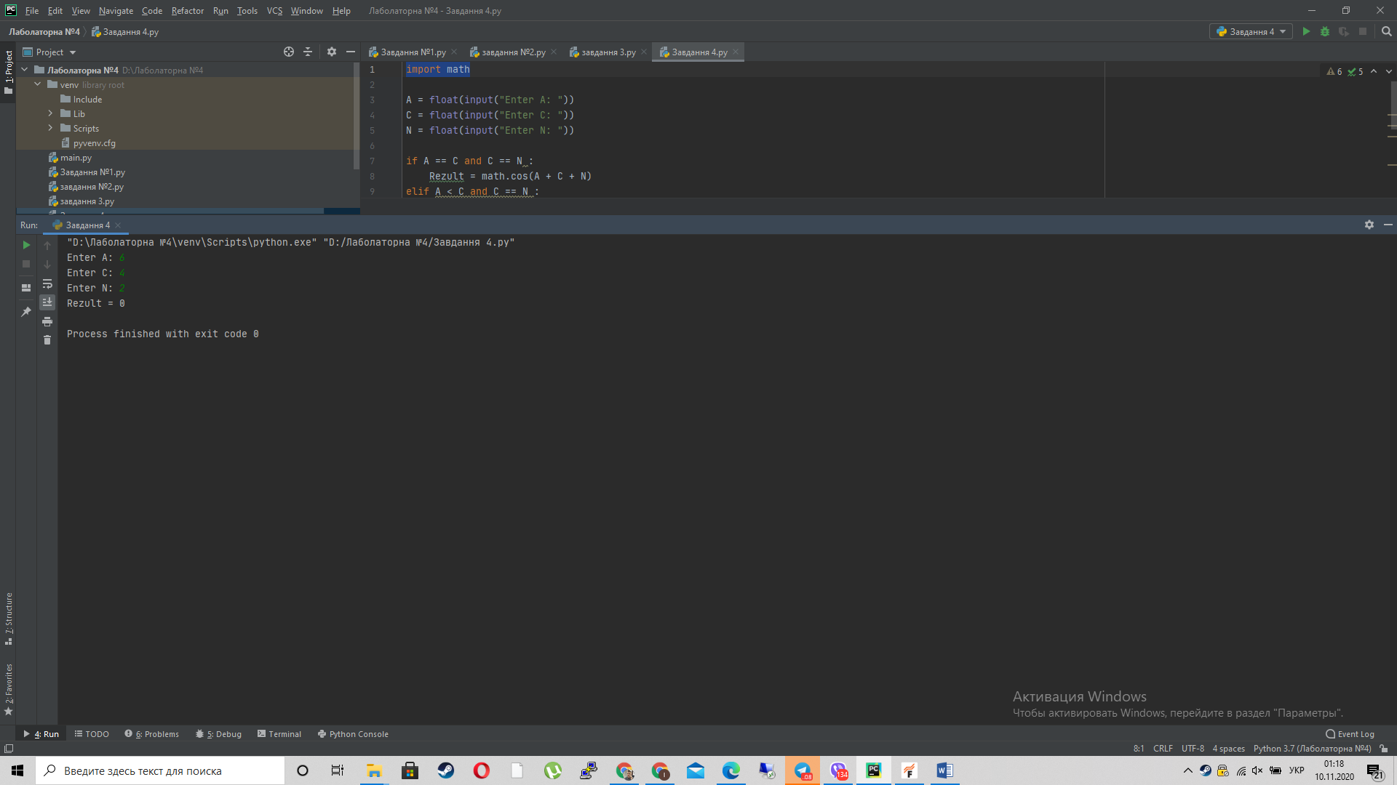

import math
A = float(input("Enter A: "))
C = float(input("Enter C: "))
N = float(input("Enter N: "))
if A == C and C == N :
Rezult = math.cos(A + C + N)
elif A < C and C == N :
Rezult = math.cos(A * C * N)
elif A < C and C < N :
Rezult = math.cos((A + C) * N)
else:
Rezult = 0
print("Rezult = {0}".format(Rezult))

